**Task8-Gemini**

**Applying Colors and Backgrounds in CSS**

CSS offers powerful tools for controlling the appearance of web elements. Colors and backgrounds are two fundamental aspects that can significantly impact the visual design of a website.

**Setting Colors**

CSS provides several methods to define colors:

* **Hexadecimal (Hex) Color Codes:** A six-character code representing the amounts of red, green, and blue in a color.
* **RGB (Red, Green, Blue) Color Model:** Specifies colors by their individual red, green, and blue components, typically ranging from 0 to 255.
* **HSL (Hue, Saturation, Lightness) Color Model:** Defines colors using hue (the color itself), saturation (the intensity of the color), and lightness (how light or dark the color is).

**Setting Backgrounds**

CSS allows you to apply various background properties:

* **Solid Color:** A single, uniform color.
* **Gradient:** A smooth transition between multiple colors.
* **Image:** An image used as the background.

**Example: Applying Colors and Backgrounds**

**HTML structure:**

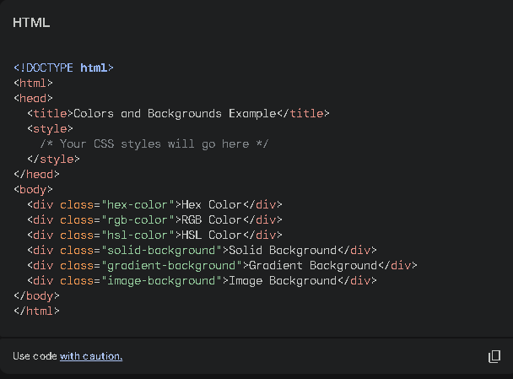

**CSS styles:**

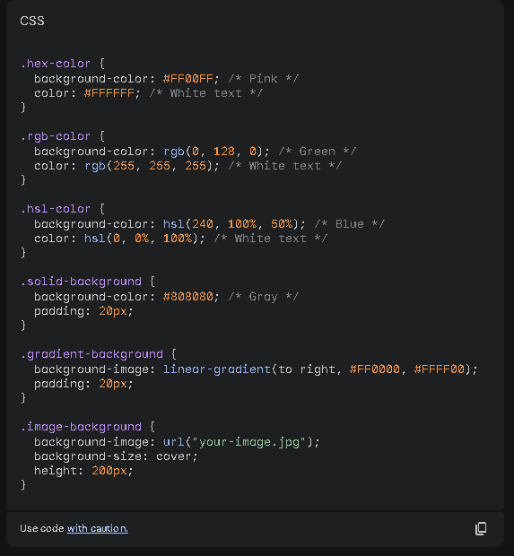

**Result:**

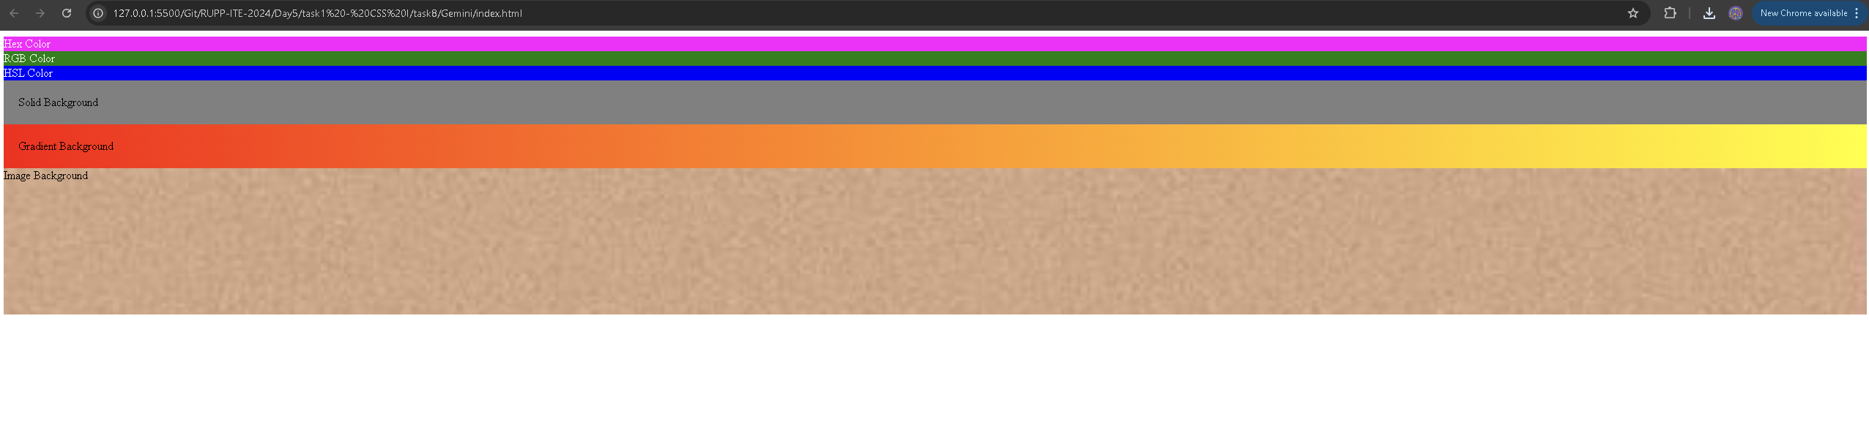

**Explanation:**

* **Hex Color:** The **background-color** property is set using a hex code for pink.
* **RGB Color:** The **background-color** property is set using RGB values for green.
* **HSL Color:** The **background-color** property is set using HSL values for blue.
* **Solid Background:** A solid gray color is applied using the **background-color** property.
* **Gradient Background:** A linear gradient from red to yellow is created using **background-image: linear-gradient().**
* **Image Background:** An image is set as the background using **background-image:** **url("your-image.jpg"). The background-size: cover** property ensures the image fills the container without distortion.

Remember to replace "**your-image.jpg"** with the actual path to your image file. You can experiment with different color values, gradients, and images to achieve various visual effects.